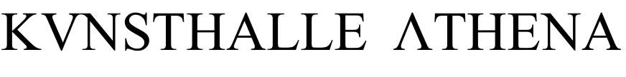

POLITICAL SPEECH # 7

Natasha Papadopoulou and Stella Dimitrakopoulou
M My Me, Part 2

Performance Μ Μy Μe, Part 2 is a movement towards self-awareness through the pursuit of the Self and its projection onto others. Two women of a strong physical resemblance project accordingly their face and body in a parallel manner. The result is a duet of hybrid figures that blurs the audience's perception in regards to their actual identities.

Bar with Greek raki
Free entrance

POLITICAL SPEECHES - July 2013

Wednesday, July 17, 20:30: Natasha Papadopoulou and Stella Dimitrakopoulou, M My Me, Part 2, performance
Thursday, July 18, 20:30: Rosemary Lee (Burning Athens / Artist in Residence), The Tyranny of the Free, artist talk

THIS MUST BE THE PLACE

Solo shows:
Katerina Kana, Thanos Kyriakides (BLIND ADAM) and Petros Touloudis
The exhibition features also works by: Sotiris Bakagiannis, Angelo Plessas, Socratis Socratous, Maria Tzanakou

Duration: May 9 - August 1, 2013
Visiting hours: Wednesday - Thursday, 18:30 - 22:00

Supported by Media Partner
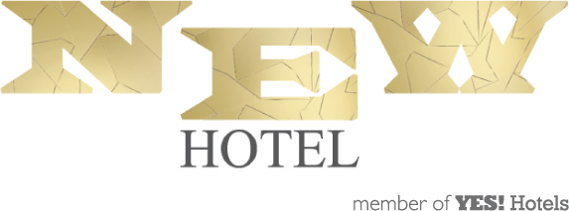

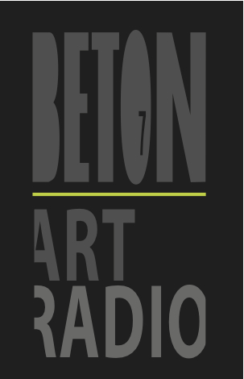

Kunsthalle Athena, 28, Kerameikou Street, Kerameikos - Metaxourgeio, Athens, Greece
www.kunsthalleathena.org

